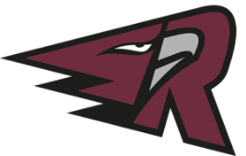
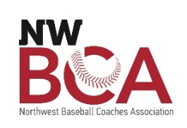

Southwest Washington Baseball Group, LLC (SWBG)
2022 Sports & Entertainment Internship Program
info@ridgefieldraptors.com

Position: Business & Community Development Intern
Supervisor: General Manager
Hours: Part-time; Starting 10 hours per week with up to 30 hours per week in the summer; some flexibility to work remotely
Pay: $17/hr.

About SWBG, LLC:

Southwest Washington Baseball Group is an ownership group of two West Coast League baseball teams in Southwest Washington; Ridgefield Raptors and Cowlitz Black Bears. In addition to the two teams, we produce the largest High School Baseball Coaches Conference in the region every January. We offer hands-on business experience for individuals looking to enter the sports and hospitality industries. SWBG values personal and professional growth and is seeking candidates who will perform within the framework of the organization, while showcasing their individual talents. We love baseball, and we love our community.

Job Description

The Business & Community Development Intern will assist with the preparation and execution of the 2022 West Coast League season for the sales and management of group attendance at the ballpark. The intern will find and convert new group leads to closed sales, manage the individual demands of each group in attendance, including group hosting and setup, and coordinate with concessions and other staff to execute food and beverage requirements and other activities as needed. We are looking for an emerging leader who is passionate about service and building community.

Primary Responsibilities:
- Build Relationships within the Community & Assist with Group Sales
  - Find Opportunities for New Leads
- Manage Group Events from Confirmation through End of Event
  - Act as the main Group contact
  - Execute day-of event needs for each group (event set-up, food & beverage, tickets)
- Manage Special Raptors Events
  - Host Family BBQ
  - Season Ticket Holder BBQ
  - Ridgefield Tailgate Nights
  - Any Rally Raptor (mascot) appearances (parades, major community events, etc)
- Assist with Concessions Management
  - Special food order for Home Plate Club
  - “All You Can Eat” Ballpark Buffet
  - Supervise concessions stands when needed

Minimum Qualifications:

- Experience in Power Point and other Microsoft Office programs
- Is highly efficient, organized, and self-driven
- Must be willing to work collaboratively on a variety of projects
- Open to direction and collaborative project building
- Must be accurate, organized, and good at prioritization
- Great communication skills

Special Consideration

- Available for 2022 Home Games
- Experience with Microsoft Office, Google Sheets
- Experience with Adobe Suite
- Experience with Wordpress

How to Apply:

- Send us a cover letter, resume to info@ridgefieldraptors.com by March 17, 2022
- Eligibility screening conducted through WorkSource SW Washington; Reach out to KLavalla@esd.wa.gov with any questions

