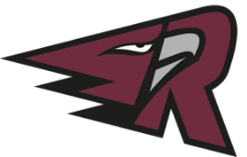
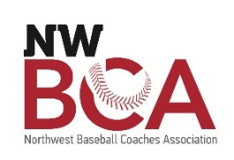

Southwest Washington Baseball Group, LLC (SWBG)
2022 Sports & Entertainment Internship Program
info@ridgefieldraptors.com

Position: Sports Management & Gameday Operations Intern
Supervisor: General Manager
Hours: Part-time; Starting 10 hours per week with up to 30 hours in the summer; some flexibility to work remotely
Pay: $17/hr

About SWBG, LLC:

Southwest Washington Baseball Group is an ownership group of two West Coast League baseball teams in Southwest Washington; Ridgefield Raptors and Cowlitz Black Bears. In addition to the two teams, we produce the largest High School Baseball Coaches Conference in the region every January. We offer hands-on business experience for individuals looking to enter the sports and hospitality industries. SWBG values personal and professional growth and is seeking candidates who will perform within the framework of the organization, while showcasing their individual talents. We love baseball, and we love our community.

Job Description

The Sports Management & Community Engagement Intern will assist with the preparation and execution of the 2022 West Coast League season for game day operations, as well as daily office work ranging from the generation of content for team websites and social media platforms, creation of publications, sponsor sales and assets, merchandise management, and other duties as assigned to enhance the coverage and visibility of the Ridgefield Raptors & Cowlitz Black Bears. Additionally, the intern will assist in the planning, organization, and implementation of local engagement, fundraisers, and mascot appearances. We are looking for an emerging leader who is passionate about service and building community.

Primary Responsibilities:
- Oversight of Team’s Ticketing Process
  - Manage Host Family Tickets
  - Manage Will Call & Pass List Tickets
  - Create Relationships with Season Ticket Holders and Key Stakeholders
- Assist with gameday operations including
  - Point of Sale setup and management
  - Gameday accounting
- Apply Strategies for Community Outreach
  - Create New Opportunities for Engagement
  - Develop Campaigns for Rally Raptor
- Lead Merchandise Management
  - Help with Creation & Execution of New Items
  - Manage Merchandise Inventory
  - Work with Marketing Department for Marketing Plan

Minimum Qualifications:

- Experience in Power Point and other Microsoft Office programs
- Is highly efficient, organized, and self-driven
- Must be willing to work collaboratively on a variety of projects
- Open to direction and collaborative project building
- Must be accurate, organized, and good at prioritization
- Great communication skills

Special Consideration

- Available for 2022 Home Games
- Experience with Accounting principles
- Experience with Microsoft Office, Google Sheets

How to Apply:

- Send us a cover letter, resume to info@ridgefieldraptors.com by March 17th, 2022
- Eligibility screening conducted through WorkSource SW Washington; Reach out to KLavalla@esd.wa.gov with any questions

