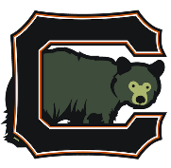
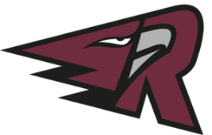
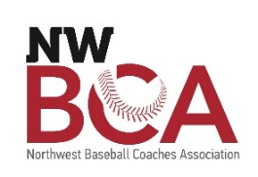

Southwest Washington Baseball Group, LLC (SWBG)
2022 Sports & Hospitality Internship Program
info@ridgefieldraptors.com

Position: Sports Media & Public Relations Intern
Supervisor: General Manager
Hours: Part-time; Starting 10 hours per week with up to 30 hours in the summer; some flexibility to work remotely
Pay: $17/hour

About SWBG, LLC:
Southwest Washington Baseball Group is an ownership group of two West Coast League baseball teams in Southwest Washington; Ridgefield Raptors and Cowlitz Black Bears. In addition to the two teams, we produce the largest High School Baseball Coaches Conference in the region every January. We offer hands-on business experience for individuals looking to enter the sports and hospitality industries. SWBG values personal and professional growth and is seeking candidates who will perform within the framework of the organization, while showcasing their individual talents. We love baseball, and we love our community.

Job Description
The Sports Media & Public Relations Intern will assist with the multiplatform needs of the organization. Including but not limited to designing promotional materials and graphic artwork, help with maintaining websites, posting on various social media platforms, and executing game-day social media presence. Plan, create & execute game-recaps for video and print applications. The Sports Media & Public Relations Intern will have creative oversight in various aspects of his or her internship while collaborating to assess the needs of the organization. We are looking for an emerging leader who is passionate about service and building community.

Primary Responsibilities:
- Work with Marketing Team to Develop and Execute Marketing Strategies (Social, Web & Print)
  - Tickets, Groups & Sponsorship Sales
  - New Merchandise
  - Game Day Promotions
- Manage Sponsorship Media Assets to ensure fulfillment
  - Social Media
  - Game Day Scripts, Radio & Streaming
- Manage Game Day Rosters
  - Series Recap/Article Writing
  - Format content & Sponsorship Advertising
- Assist with mobile and web design and functionality
  - Update Website with Post Game information / Beat Articles
  - Update website home page in alignment with current marketing strategies and sponsorships
- Research and implement various social media campaigns to enhance fan engagement
- Create photography shot list for game-day & community events; Step in as photographer when needed
- Design needed collateral for website, print materials, email, social media (Facebook, Instagram, Twitter)
- Edit photos and video to align with brand standards
Minimum Qualifications:

- Experience in Power Point and other Microsoft Office programs
- Experience with Adobe Suite
- Experience with Video Editing
- Is highly efficient, organized, and self-driven
- Must be willing to work collaboratively on a variety of projects
- Open to direction and collaborative project building
- Must be accurate, organized, and good at prioritization
- Great communication skills

Special Consideration

- Available for 2022 Home Games
- Experience with Wordpress (website management)

How to Apply:

- Send us a cover letter, resume, portfolio of your work to info@ridgefieldraptors.com by March 17, 2022
- Eligibility screening conducted through WorkSource SW Washington; Reach out to KLavalla@esd.wa.gov with any questions

